Assignment No -: 11

Que 1-: Write a query that uses a sub query to obtain all orders for the customer named ‘Cisneros’. Assume you do not Know his Customer number(cnum).

kd2_83598>select * from orders
-> where snum=
-> (select Snum from Customers where Cname="Cisneros");

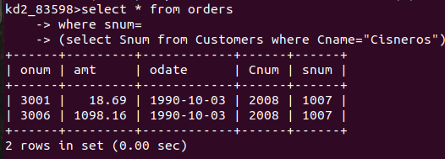

Que 2-: Write A Query That Produces The names And Ratings of all customers who have above Average orders.

kd2_83598>select Customers.snum,Cname,Rating,amt from orders,Customers
-> where orders.snum=Customers.Snum and amt>
-> (select avg(amt) from orders);
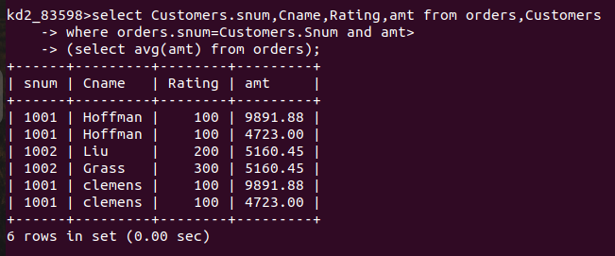
Que 3 -:

kd2_83598>select salespeople.Snum,salespeople.Sname from orders,salespeople
-> where salespeople.Snum=orders.snum
-> group by salespeople.Snum,salespeople.Sname
-> having sum(amt)>
-> (select max(amt) from orders);

